# **Smart Jewellery Security System**

**A Project Report**

Submitted in partial fulfillment of the

Requirements for the award of the Degree of

**BACHELOR OF SCIENCE (INFORMATION TECHNOLOGY)**

**By**

Gaheythri Ponnaboina & Om Anand Padalkar

**Under the esteemed guidance of**

**Mrs. Shital Patil**

**Lecturer**



**DEPARTMENT OF INFORMATION TECHNOLOGY**

**VIVEKANAND EDUCATION SOCIETY’S**

**COLLEGE OF ARTS, SCIENCE AND COMMERCE**

**(Autonomous)**

***Affiliated to University of Mumbai***

**CHEMBUR MUMBAI – 400071**

**MAHARASHTRA**

**2023-2024**

**Proforma for the Approval Project Proposal**

PNR No.:2021016401556932 Roll No.:44

1. Name of the Student

Gaheytrhi Ponnaboina

2. Title of the Project

Smart Jewellery Security System

3.Name of the Guide

Mrs. Shital Patil

4.Teaching Experience of the Guide

17 years

5.Is this your first submission? Yes No

Signature of Student Signature of Guide

Date: …………….. Date: ……………..

**Signature of the Coordinator**

**Date:………………………………**

**Proforma for the Approval Project Proposal**

PNR No.:2021016401560292 Roll No.:82

1. Name of the Student

Om Anand Padalkar

2. Title of the Project

Smart Jewellery Security System

3.Name of the Guide

Mrs. Shital Patil

4.Teaching Experience of the Guide

17 years

5.Is this your first submission? Yes No

Signature of Student Signature of Guide

Date: …………….. Date: ……………..

**Signature of the Coordinator**

**Date:………………………………**

**VIVEKANAND EDUCATION SOCIETY’S**

**COLLEGE OF ARTS, SCIENCE AND COMMERCE**

**(Autonomous)**

***Affiliated to University of Mumbai***

**CHEMBUR-MAHARASHTRA-400071**

**DEPARTMENT OF INFORMATION TECHNOLOGY**



**CERTIFICATE**

# This is to certify that the project entitled, **" Smart Jewellery Security System"**, is bonafide work of Gaheytrhi Ponnaboinasubmitted in partial fulfillment of the requirements for the award of degree of BACHELOR OF SCIENCE in INFORMATION TECHNOLOGY from University of Mumbai.

**Internal Guide Coordinator**

**External Examiner**

**Date: College Seal**

**VIVEKANAND EDUCATION SOCIETY’S**

**COLLEGE OF ARTS, SCIENCE AND COMMERCE**

**(Autonomous)**

***Affiliated to University of Mumbai***

**CHEMBUR-MAHARASHTRA-400071**

**DEPARTMENT OF INFORMATION TECHNOLOGY**



**CERTIFICATE**

# This is to certify that the project entitled, **" Smart Jewellery Security System"**, is bonafide work of **Om Anand Padalkar** submitted in partial fulfillment of the requirements for the award of degree of BACHELOR OF SCIENCE in INFORMATION TECHNOLOGY from University of Mumbai.

**Internal Guide Coordinator**

**External Examiner**

**Date: College Seal**

**ABSTRACT**

The “**Smart Jewellery Security System**” is a IOT based project .This is device specially made for shops to protect the shop from theifs.In this project CCTV (closed-circuit television) camera systems are installed to protect your home and shops from burglary and break-ins. But with our busy lives, it is not possible to monitor it 24*7. So, we need a more reliable and robust smart security system that can notify us when someone breaks into our shop or home.When a thief enters a jewellery shop, the shop owner automatically gets a notification on his/her phone. Also, the device automatically calls the cops while the thief is busy stealing the valuables. This is possible with our smart device that we are going to make.This system tracks the thief movements and their actions that are captured in camera.We can monitor our shop/home security from anywhere using this system.

**ACKNOWLEDGEMENT**

We thank the people who were a part of this project in numerous ways, people who gave their unending support right from the stage the project idea was conceived.

The four things that go on to make a successful endeavour are dedication, hard work, patience and correct guidance.

We would like to thank our Principal **Dr. Mrs. Anita Kanwar** who has always been the source of inspiration.

We are also thankful to **Mrs. Shital Patil, our** In-charge coordinator who was very much kind enough to give us an idea and guide us throughout our project work.

And a heartfelt Thankyou to **Abhishek Padalkar** for helping us .We couldn’t have done it without your expertise and support.Thank you so much for you tremendous help!!

We take this opportunity to offer sincere thanks to Mrs. **Shital Patil** our project guide who helped us throughout the project documentation**.**

We are thankful to all the teaching staff (I.T) who shared their experience and gave their suggestions for developing our project in a better way.

We are also thankful to **all teaching and non-teaching staff(I.T)** who shared their experience and gave their suggestions for helping us out in Project Documentation.

**DECLARATION**

I hereby declare that the project entitled, “Smart Jewellery Security System” done at the place where the project is done, has not been in any case duplicated to submit to any other university for the award of any degree. To the best of my knowledge other than me, no one has submitted to any other university. The project is done in partial fulfilment of the requirements for the award of the degree of BACHELOR OF SCIENCE (INFORMATION TECHNOLOGY) to be submitted as a final semester project as part of our curriculum.

Name and Signature of the Student

## 

|  |
| --- |
| **Chapter 1: Introduction**  **TABLE OF CONTENTS**  1.1 Background  1.2 Objectives  1.3 Purpose and Scope  1.4 Applicability  1.5 Organisation of report |
| **Chapter 2: Survey of technologies**  2.1 Justification of selection of Technology |
| **Chapter 3: System Analysis**  3.1 Existing System  3.2 Proposed System  3.3 Requirement Analysis  3.4 Hardware Requirements  3.5 Software Requirements  3.6 Planning and scheduling   * PERT AND GANTT |
| **Chapter 4: System Design**  4.1 Module Division  4.2 Data Dictionary  4.3 ER Diagrams  4.4 DFD  4.5 UML Diagrams   * Use case * Activity * Sequence * State transition diagram   For IOT and Embedded projects   * Use case * Component diagram * Circuit and pin diagram * Deployment diagram |

**CHAPTER 1:-INTRODUCTION**

* 1. **Background**

Its is a Iot based device for Home and shop security. Nowadays, In our busy lives it is not possible to monitor Home /shop 24*7 . So, we need a more reliable and robust smart security system that can notify us when someone breaks into our shop or home. When thief enters a jewellery shop, the shop owner automatically gets a notification on his/her phone. Also, the device automatically calls the cops while the thief is busy stealing the valuables. This is possible with our smart device that we are going to make.

The basic definition of home automation system is to create a networking between home appliance and devices so that all the appliances in a house can be controlled through a single machine. As we know that today world is progressing very fast, things are becoming easy then before. People are considering the automatic devices instead of manual devices. They just want an easier approach to some device. This field of automation is growing very fast. Internet is the basic part of the world’s communication. It is also being used to communicate between the devices to operate accordingly.

* 1. **Objectives:**
* Alerts and Notifications: Send alerts and notifications in real-time in case of security breaches or unusual activities.
* Integration: Integrate various devices like security cameras, door locks, motion sensors, and smart thermostats into a centralized system.
* And other details like:-
* It is energy saving device.
* Calls the cop automatically
* Notify to owner of shop on the spot
* Alert alarm
* Track the Location
  1. **Purpose:-**

* ➢ Modern home/shop security systems feature home automation capabilities that offer convenience and energy savings, which helps justify the extra cost of a security system.
* ➢ Internet-connected lights and thermostats paired with a security system can adjust themselves to save energy when the system is armed, while smart door locks and connected garage door openers give you a secure way to let friends and family into your home.
* ➢ No matter where you live, being at home should always feel safe. Having a wireless home security system can give you the added peace of mind you and your family need to feel safe around the clock. When you consider purchasing a security system, there are three objectives the device should meet. These objectives include minimizing break-ins, protecting your possessions, and avoiding danger.
* ➢ We have designed an interesting and cheap home/shop security alarm. This Gadget helps you to protect your house/shop from thieves.
  + 1. **SCOPE:-**
* The sensors placed on the door informs the home owner as soon as the door is opened by sending a Push notification. The user will get this notification irrespective of whether the phone is locked or unlocked or even if any other app is opened at the moment
* This was the main objective of the project, which is the user feels safe and not worry about any intrusion or break-ins when he is away from home.
* This setup can also be used in commercial offices where some areas are restricted for certain personnel, such a system will immediately inform the administrator of any unauthorized personnel trying to access such an area. Therefore the extensibility and applicability of such a system is only limited only by the imagination.
* We can add a keypad to arm or disarm the alarm . We can determine the position of the intruder and then send a SMS to the concerned authorities.
* This is a basic motion-sensing alarm that detects when someone enters the shop. When an intruder is detected, it activates a siren.
* Our body generates heat energy in the form of infrared which is invisible to human eyes. But it can be detected by electronic sensor. This type of sensor is made up of crystalline material that is Pyroelectric.

**1.3.3 Aplicability:-**

* The IOTs based home/shop security and automation is very useful for remote users. Any home can be monitored and controlled by using the prototype implemented in this paper. This IOTs based system is the building block of all internet based diverse applications.
* The system developed in this paper is cost effective solution of IOT applications. The modules used in its formation are light, easy to use and cost effective. It also enables easy operation and quick access of information.
* It enables user to access file by computer anywhere in the world. It extends internet productivity gain to things not just to people as more data is generated by things than just by people. It is a prototype which provides reliable, cost effective and efficient IOT applications solution
* The given system is handy and portable, and thus can be easily carried from one place to another.
* The circuitry is not that complicated and thus can be easily troubleshooted. The given system sets off a powerful buzzer, and it is effective as any other alarm system available in the market.
  1. **Achivements:-**

Safety is the most important requirement of home for people. For that we need an automated system which can be used for home/shop security. With the development of embedded technology, network and automatic control technology, a remote home security monitoring and alarming system . This type of motion sensing alarm system can be easily employable for security purposes at banks, various offices and even for sensitive establishments such as for military. We can easily set up this system for household purposes also.

Smart systems can include detectors that alert you to the presence of smoke or dangerous gases. Perhaps the most significant benefit is the peace of mind that comes from knowing your shop is secure, even when you're not there.

**Chapter 2**

**Survey of technologies**

|  |  |
| --- | --- |
| FRONT END/GUI TOOLS | .Net Technologies, Java, HTML/CSS |
| DBMS/BACK END | Oracle, SQL Plus, MySQL, SQLServer |
| LANGUAGES | C, C++, Java, VC++, C#, R, Python |
| SCRIPTING LANGUAGES | PHP, JSP, JavaScript |
| .NET Platform | C# .Net, Visual C# .Net, ASP .Net |

**2.1 FRONT END/GUI TOOLS:-**

1)HTML CSS

The structure of the webpages would be designed by HTML scripting to order content.HTML is used to markup different kinds of vontent (eg:-Tables,paragraphs,lists,hyperlinks,images,videos, etc.)

On webpages.

CSS makes the front-end of a website shine and it creates a great user experience.

Javascript allows user to interact with webpages.It allow us to add dynamic behaviour.

**DBMS/BACKEND**

1)PHP

PHP is an HTML-embedded scripting language. Much of its syntax is borrowed from C, Java and Perl with a couple of unique PHP-specific features thrown in. The goal of the language is to allow web developers to write dynamically generated pages quickly.

It is powerful enough to be at the core of the biggest blogging system on the web (WordPress)!

It is deep enough to run large social networks.

It is also easy enough to be a beginner's first server side language.

PHP runs on various platforms (Windows, Linux, Unix, Mac OS X, etc.)

PHP is compatible with almost all servers used today (Apache, IIS, etc.)

PHP supports a wide range of databases

PHP is free. Download it from the official PHP resource: www.php.net

PHP is easy to learn and runs efficiently on the server side

**Languages**

C/C++

Code written in C/C++ can be easily ported to various microcontrollers and embedded systems, making it versatile for different IoT hardware platforms.

C/C++ provides direct memory manipulation and manual memory management, allowing developers to optimize code for resource-constrained IoT devices.

Having wealth of knowledge, resources, and support available.

* **JUSTIFICATION OF PLATFORM**
  + The iot based project smart jewellery shop security integrates diifferent languages and scripting techonologies such as Java,HTML,JAVASCRIPT along with different libraries.
  + MongoDB is designed to scale horizontally, which is crucial in IoT projects where the number of connected devices and data volume can grow rapidly. You can easily add more servers or clusters to handle increased data traffic.
  + MongoDB's JSON-like document format is easy for developers to work with, especially when dealing with sensor data that often comes in JSON format.
  + HTML and JavaScript are essential for creating web-based user interfaces (UIs) to interact with IoT devices. They allow you to build intuitive dashboards and control panels that users can access through web browsers on various devices

**CHAPTER 3**

**System Analysis**

**3.1)Existing System:-**

Systems like lazer maze security systems,motion sensing security system,4WD Security system,door secure etc, these are all security devices .User can easily observe everything through a smartphone.

* Below are some existing systems for security devices:-
* Loud security Alarm:- It features a microcontroller, meaning you can connect it to your amplifier, so whenever it goes off, even your neighbor a hundred yards away will hear it. And it’s not just loud: it can issue voice commands too—for instance, “step away from the porch”—so even the most daring burglars freeze in their tracks and are compelled to turn back.
* Lazer maze security system:- We’ve all seen it in a movie: a valuable artifact, protected by a maze of lasers that trigger the alarm to go off whenever they detect movement. Now, imagine having that as part of your home’s security system. It would be awesome!
* Motion-Sensing security system:- Motion-sensing security systems can cost an arm and a leg, but why spend your hard-earned money on one when you can build one at nearly a quarter of the cost? You will need an Arduino Uno, a PIR motion sensor, a couple of jumper wires, a loud buzzer, a power supply, and all the supplies and instructions in this easy-to-follow Instructable. While you're at it, here are some other interesting beginner projects using Arduino.
* 4WD security Robot:- If you love taking strolls around your yard just to see how everything is but never get the time to do it, you’ll love this Arduino-controlled 4-wheel drive security robot. It features a pair of cameras, a controller with more than 400 yards range, and a reflector to illuminate the surrounding area.

**3.2 Proposed System:-**

Centralized Control and Monitoring: IoT Gateway: Set up a central IoT gateway to connect and manage all IoT devices. It ensures seamless communication between devices and the central control system.User Interface: Develop a user-friendly web or mobile application. This interface allows the shop owner or security personnel to monitor the entire shop's security status remotely, access live video feeds, and receive real-time alerts.

3. Real-time Alerts and Responses: Alert System: Configure the system to generate loud alarms and flashing lights in case of a security breach. This deters potential intruders and alerts nearby individuals.Instant Notifications: Send immediate notifications via SMS, email, or push notifications to the shop owner and designated security personnel when any security breach occurs.Automated Responses: Implement automated actions such as locking down specific areas, activating additional security measures, or notifying law enforcement based on the severity of the breach.

**3.3 Requirement Analysis:**

Problem Definition:- The jewelry retail industry faces significant challenges in ensuring the security of valuable merchandise and the premises against theft, unauthorized access,and potential emergencies.

Conventional security measures often fall short in providing real-time monitoring, instant alerts, and proactive responses to mitigate security threats. Therefore, there is a pressing need to develop and implement an advanced smart securitysystem for jewelry shops that leverages IoT technology to address these challenges effectively.

Key Problem Areas: Real-Time Monitoring: Traditional security systems lack real-time monitoring capabilities, making it difficult to detect and respond to security breaches promptly. Timely Alerts: Existing security systems often rely on manual intervention to raise alarms, resulting in delayed responses to potential threats.Integration with Emergency Services: Rapid communication and integration with emergency services, such as law enforcement and fire departments, are lacking in traditional security systems.

**3.3.2 Requirement Specification:**

Requirement specification establishes the basis for an agreement between user’s and client how the AI chatbot should function.

• The system shall include IoT-enabled surveillance cameras placed at strategic locations throughout the shop.

• Cameras shall provide high-definition video streaming and support night vision. • Cameras shall have pan, tilt, and zoom capabilities for comprehensive coverage.

• Motion Detection:

• IoT motion sensors shall be installed at entry points and key areas within the shop.

• The system shall detect and differentiate between normal customer movements and suspicious activities.

• Contact sensors shall be deployed on all doors and windows.

• The system shall instantly notify authorized personnel when doors or windows are opened or breached.

**3.4)Hardware Requirements:**

The hardware requirements for smart jewellery security system with features like face detection,motion detection,alarm notification,these typically include:-

|  |  |  |
| --- | --- | --- |
| Component name | Description | Quantity |
| Ardino Uno | For programming | 1 |
| Phir motion sensor | To detect motions | 1 |
| Bluetooth HC 05 | To send OTP | 2 |
| Wires | For connection | 20cm |
| Battery | 5 to 12v | 1 |

**3.5) Software Requirements:**

The software requirements for a jewelry shop security project using IoT are crucial for managing and controlling the IoT devices, processing data, and ensuring effective security measures. Here's a list of key software requirements for the project:

• Platform for configuring and managing IoT devices such as cameras, sensors, and detectors.

• Capabilities for device provisioning, firmware updates, and remote configuration.

• Security Monitoring and Control Application:

• Web-based or mobile application for real-time monitoring and control of the security system.

• User-friendly interface with intuitive controls and visualizations.

• Software for processing and streaming live video feeds from IoT-enabled cameras to the control application.

• Low-latency video streaming to ensure real-time monitoring.

MongoDB a noSQL database used to store metadata.

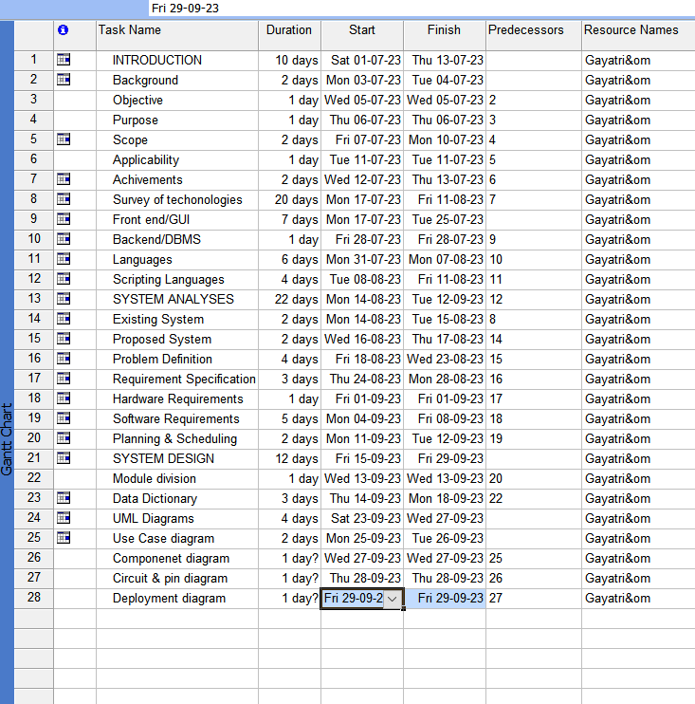**PERT & GANTT CHART**

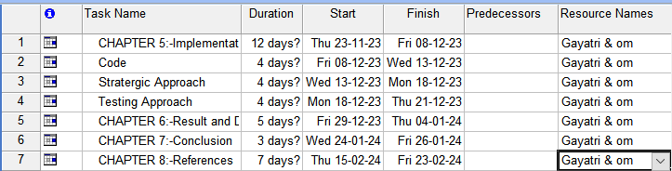

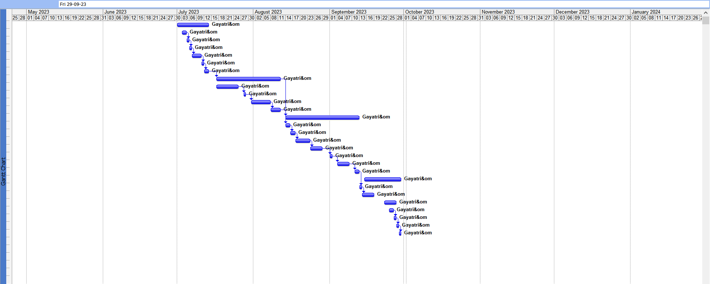

**Pert Chart**

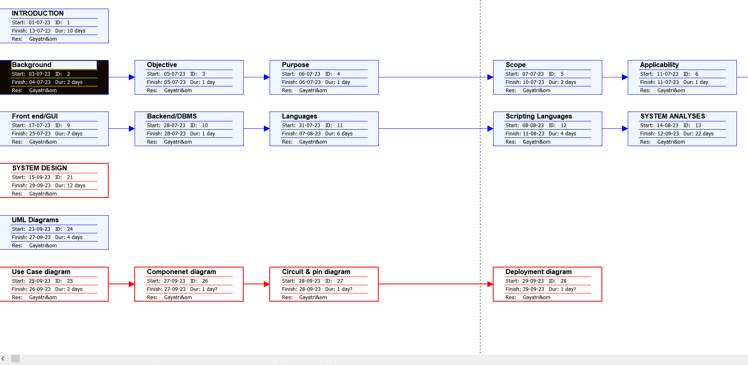

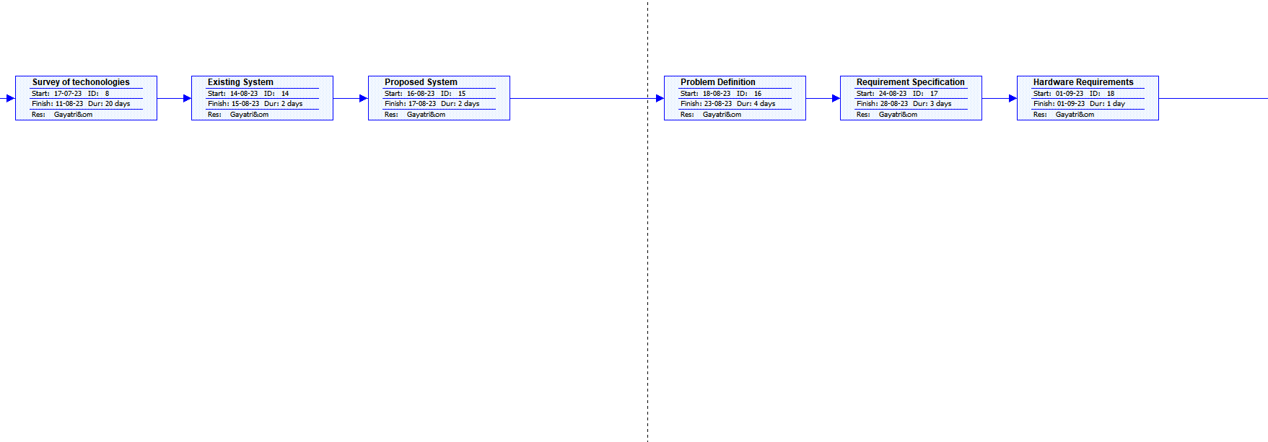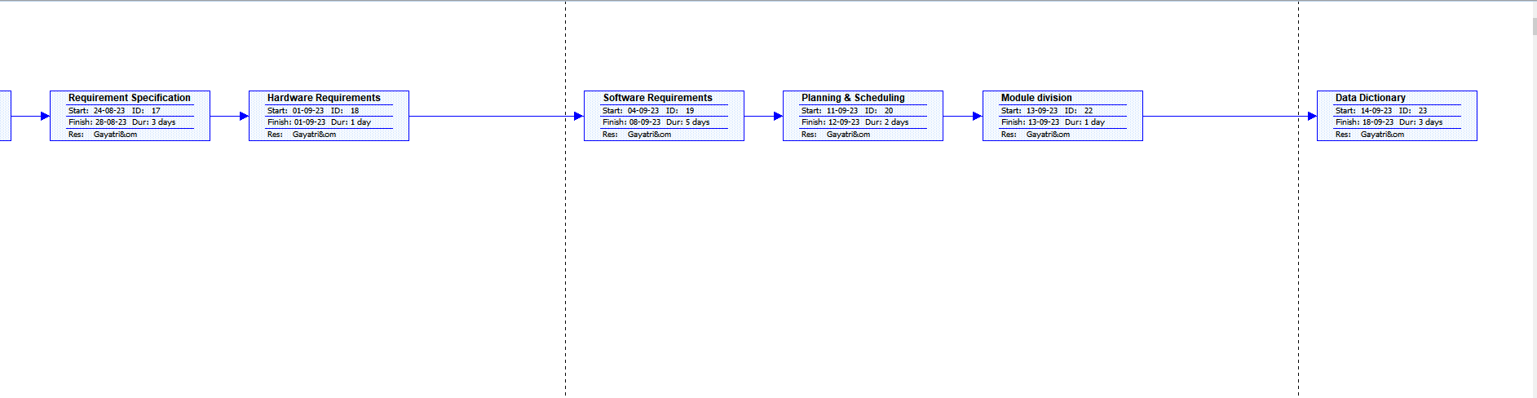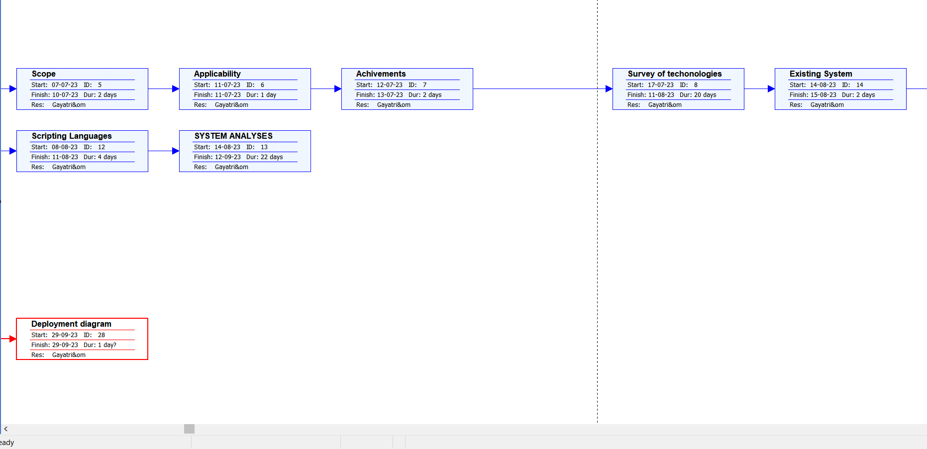 **CHAPTER 4**

**System Design**

**4.1)Module Division**

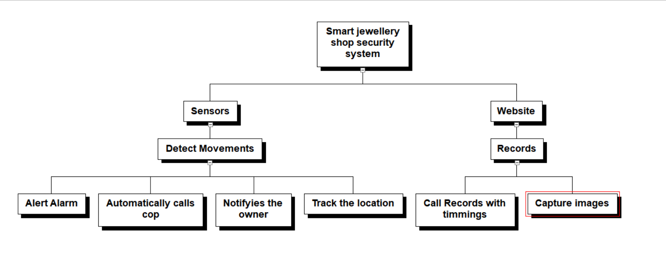

**\**

**4.2)Data Dictionary**

**1.Owner Data**

|  |  |  |  |
| --- | --- | --- | --- |
| Serial  no. | Column Name | Data type | Descrption |
| 1 | Username(PK) | Varchar2(30) | Username of the user |
| 2 | Email | Varchar2(100) | Email id of the user |
| 3 | Password | Varchar2(15) | Password of the user |

**2.Captured Data**

|  |  |  |  |
| --- | --- | --- | --- |
| Serial  no. | Column Name | Data Type | Description |
| 1 | Capture_id | Varchar2(50) | ID number for captured photo |
| 2 | Capture_date | Varchar2(30) | Record the date of captured image |

**4.3)UML Diagrams**

**1)Use Diagram**

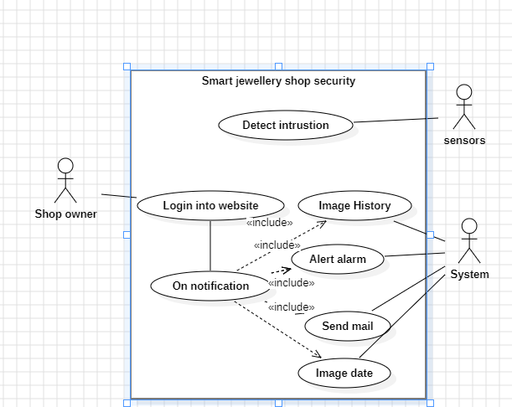

**1)Use Case Diagram**

**2)Component Diagram**

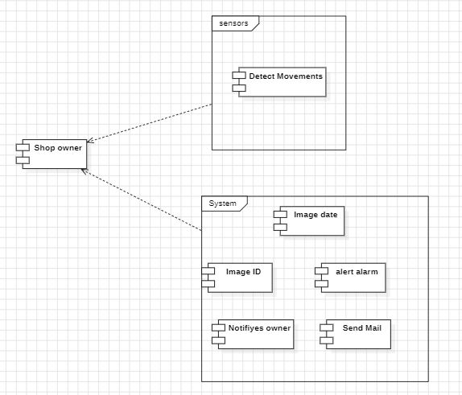

3)Circuit Diagram

**4)Pin Diagram**

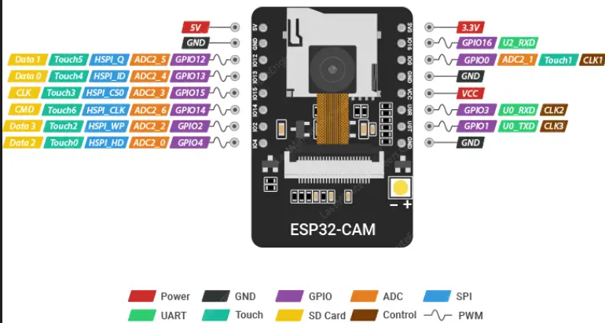

**5)Deployment diagram**

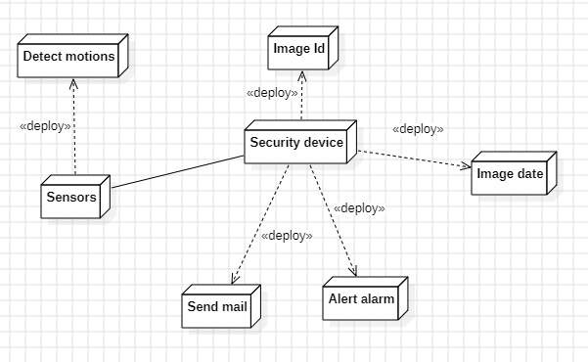**Chapter 5:Implementation and Testing**

5.1 CODE:-

Sending photos to website

#include <WiFi.h>

#include "soc/soc.h"

#include "soc/rtc_cntl_reg.h"

#include "esp_camera.h"

#define PWDN_GPIO_NUM 32

#define RESET_GPIO_NUM -1

#define XCLK_GPIO_NUM 0

#define SIOD_GPIO_NUM 26

#define SIOC_GPIO_NUM 27

#define Y9_GPIO_NUM 35

#define Y8_GPIO_NUM 34

#define Y7_GPIO_NUM 39

#define Y6_GPIO_NUM 36

#define Y5_GPIO_NUM 21

#define Y4_GPIO_NUM 19

#define Y3_GPIO_NUM 18

#define Y2_GPIO_NUM 5

#define VSYNC_GPIO_NUM 25

#define HREF_GPIO_NUM 23

#define PCLK_GPIO_NUM 22

// LED Flash PIN (GPIO 4)

#define FLASH_LED_PIN 4

#define PIR_SENSOR_IN 2

//----------- Network credentials.

const char* ssid = "Padalkar";

const char* password = "om210404";

.

unsigned long previousMillis = 0;

const int Interval = 5000; //--> Photo capture every 20 seconds.

// Server Address or Server IP.

String serverName = "192.168.162.1"; //--> computer's IP address or your Domain name.

// The file path "upload_img.php" on the server folder.

String serverPath = "/ESP32CAM/upload_img.php";

// Server Port USED.

const int serverPort = 80;

// Variable to set capture photo with LED Flash.

// Set to "false", then the Flash LED will not light up when capturing a photo.

// Set to "true", then the Flash LED lights up when capturing a photo.

bool LED_Flash_ON = true;

// Initialize WiFiClient.

WiFiClient client;

void sendPhotoToServer() {

String AllData;

String DataBody;

Serial.println();

Serial.println("-----------");

Serial.println("Taking a photo...");

if (LED_Flash_ON == true) {

// digitalWrite(FLASH_LED_PIN, HIGH);

delay(1000);

}

for (int i = 0; i <= 3; i++) {

camera_fb_t * fb = NULL;

fb = esp_camera_fb_get();

if(!fb) {

Serial.println("Camera capture failed");

Serial.println("Restarting the ESP32 CAM.");

delay(1000);

ESP.restart();

return;

}

esp_camera_fb_return(fb);

delay(200);

}

camera_fb_t * fb = NULL;

fb = esp_camera_fb_get();

if(!fb) {

Serial.println("Camera capture failed");

Serial.println("Restarting the ESP32 CAM.");

delay(1000);

ESP.restart();

return;

}

if (LED_Flash_ON == true) digitalWrite(FLASH_LED_PIN, LOW);

Serial.println("Taking a photo was successful.");

Serial.println("Connecting to server: " + serverName);

if (client.connect(serverName.c_str(), serverPort)) {

Serial.println("Connection successful!");

String post_data = "--dataMarker\r\nContent-Disposition: form-data; name=\"imageFile\"; filename=\"ESP32CAMCap.jpg\"\r\nContent-Type: image/jpeg\r\n\r\n";

String head = post_data;

String boundary = "\r\n--dataMarker--\r\n";

uint32_t imageLen = fb->len;

uint32_t dataLen = head.length() + boundary.length();

uint32_t totalLen = imageLen + dataLen;

client.println("POST " + serverPath + " HTTP/1.1");

client.println("Host: " + serverName);

client.println("Content-Length: " + String(totalLen));

client.println("Content-Type: multipart/form-data; boundary=dataMarker");

client.println();

client.print(head);

uint8_t *fbBuf = fb->buf;

size_t fbLen = fb->len;

for (size_t n=0; n<fbLen; n=n+1024) {

if (n+1024 < fbLen) {

client.write(fbBuf, 1024);

fbBuf += 1024;

}

else if (fbLen%1024>0) {

size_t remainder = fbLen%1024;

client.write(fbBuf, remainder);

}

}

client.print(boundary);

esp_camera_fb_return(fb);

int timoutTimer = 10000;

long startTimer = millis();

boolean state = false;

Serial.println("Response : ");

while ((startTimer + timoutTimer) > millis()) {

Serial.print(".");

delay(200);

// Skip HTTP headers

while (client.available()) {

char c = client.read();

if (c == '\n') {

if (AllData.length()==0) { state=true; }

AllData = "";

}

else if (c != '\r') { AllData += String(c); }

if (state==true) { DataBody += String(c); }

startTimer = millis();

}

if (DataBody.length()>0) { break; }

}

client.stop();

Serial.println(DataBody);

Serial.println("-----------");

Serial.println();

}

else {

client.stop();

DataBody = "Connection to " + serverName + " failed.";

Serial.println(DataBody);

Serial.println("-----------");

}

}

void setup() {

// put your setup code here, to run once:

// Disable brownout detector.

WRITE_PERI_REG(RTC_CNTL_BROWN_OUT_REG, 0);

Serial.begin(115200);

Serial.println();

pinMode(FLASH_LED_PIN, OUTPUT);

// Setting the ESP32 WiFi to station mode.

WiFi.mode(WIFI_STA);

Serial.println();

//---------------------------------------- The process of connecting ESP32 CAM with WiFi Hotspot / WiFi Router.

Serial.println();

Serial.print("Connecting to : ");

Serial.println(ssid);

WiFi.begin(ssid, password);

// The process timeout of connecting ESP32 CAM with WiFi Hotspot / WiFi Router is 20 seconds.

// If within 20 seconds the ESP32 CAM has not been successfully connected to WiFi, the ESP32 CAM will restart.

// I made this condition because on my ESP32-CAM, there are times when it seems like it can't connect to WiFi, so it needs to be restarted to be able to connect to WiFi.

int connecting_process_timed_out = 20; //--> 20 = 20 seconds.

connecting_process_timed_out = connecting_process_timed_out * 2;

while (WiFi.status() != WL_CONNECTED) {

Serial.print(".");

delay(500);

if(connecting_process_timed_out > 0) connecting_process_timed_out--;

if(connecting_process_timed_out == 0) {

Serial.println();

Serial.print("Failed to connect to ");

Serial.println(ssid);

Serial.println("Restarting the ESP32 CAM.");

delay(1000);

ESP.restart();

}

}

Serial.println();

Serial.print("Successfully connected to ");

Serial.println(ssid);

//---------------------------------------- Set the camera ESP32 CAM.

Serial.println();

Serial.print("Set the camera ESP32 CAM...");

camera_config_t config;

config.ledc_channel = LEDC_CHANNEL_0;

config.ledc_timer = LEDC_TIMER_0;

config.pin_d0 = Y2_GPIO_NUM;

config.pin_d1 = Y3_GPIO_NUM;

config.pin_d2 = Y4_GPIO_NUM;

config.pin_d3 = Y5_GPIO_NUM;

config.pin_d4 = Y6_GPIO_NUM;

config.pin_d5 = Y7_GPIO_NUM;

config.pin_d6 = Y8_GPIO_NUM;

config.pin_d7 = Y9_GPIO_NUM;

config.pin_xclk = XCLK_GPIO_NUM;

config.pin_pclk = PCLK_GPIO_NUM;

config.pin_vsync = VSYNC_GPIO_NUM;

config.pin_href = HREF_GPIO_NUM;

config.pin_sscb_sda = SIOD_GPIO_NUM;

config.pin_sscb_scl = SIOC_GPIO_NUM;

config.pin_pwdn = PWDN_GPIO_NUM;

config.pin_reset = RESET_GPIO_NUM;

config.xclk_freq_hz = 20000000;

config.pixel_format = PIXFORMAT_JPEG;

// init with high specs to pre-allocate larger buffers

if(psramFound()){

config.frame_size = FRAMESIZE_UXGA;

config.jpeg_quality = 10; //--> 0-63 lower number means higher quality

config.fb_count = 2;

} else {

config.frame_size = FRAMESIZE_SVGA;

config.jpeg_quality = 8; //--> 0-63 lower number means higher quality

config.fb_count = 1;

}

// camera init

esp_err_t err = esp_camera_init(&config);

if (err != ESP_OK) {

Serial.printf("Camera init failed with error 0x%x", err);

Serial.println();

Serial.println("Restarting the ESP32 CAM.");

delay(1000);

ESP.restart();

}

sensor_t * s = esp_camera_sensor_get();

s->set_framesize(s, FRAMESIZE_SXGA); //--> UXGA|SXGA|XGA|SVGA|VGA|CIF|QVGA|HQVGA|QQVGA

Serial.println();

Serial.println("Set camera ESP32 CAM successfully.");

Serial.println();

Serial.print("ESP32-CAM captures and sends photos to the server every 20 seconds.");

}

void loop() {

seconds (see Interval variable).

unsigned long currentMillis = millis();

if (currentMillis - previousMillis >= Interval) {

previousMillis = currentMillis;

sendPhotoToServer();

}

}

Html/css code

**Login1.php**

**Website Page**

<!DOCTYPE html>

<html lang="en">

<head>

<meta charset="UTF-8">

<meta name="viewport" content="width=device-width, initial-scale=1.0">

<title>Login Page</title>

<style>

body {

margin: 0;

padding: 0;

background: #7fffd4;

display: flex;

justify-content: center;

align-items: center;

height: 100vh;

}

.login-box {

width: 300px;

padding: 40px;

position: absolute;

top: 50%;

left: 50%;

transform: translate(-50%, -50%);

background: #FF7F50;

text-align: center;

border-radius: 8px;

box-shadow: 0 15px 25px rgba(0, 0, 0, 0.5);

}

.login__box {

grid-template-columns: max-content 1fr;

align-items: center;

column-gap: 0.75rem;

border-bottom: 2px solid var(--white-color);

}

.textbox {

position: relative;

margin-bottom: 30px;

}

.textbox input {

width: 100%;

padding: 10px;

background: #f0f0f0;

border: none;

outline: none;

color: #333;

font-size: 18px;

border-radius: 5px;

}

.btn {

width: 100%;

background: #333;

border: none;

padding: 10px;

cursor: pointer;

font-size: 18px;

color: #fff;

border-radius: 5px;

}

.login__img {

position: absolute;

width: 100%;

height: 100%;

object-fit: cover;

object-position: center;

}

</style>

</head>

<body>

<div class="login-box">

<h2>Login</h2>

<?php

$msg = '';

if (isset($_POST['login']) && !empty($_POST['username']) && !empty($_POST['password'])) {

if ($_POST['username'] == 'username' && $_POST['password'] == 'password') {

$_SESSION['valid'] = true;

$_SESSION['timeout'] = time();

$_SESSION['username'] = 'username';

header("Location: cap.php"); // Redirect to dashboard

exit();

} else {

$msg = 'Wrong username or password';

}

}

?>

<div class="login">

<form method="post" action="<?php echo htmlspecialchars($_SERVER['PHP_SELF']); ?>">

<div class="textbox">

<input type="text" placeholder="Username" name="username" required>

</div>

<div class="textbox">

<input type="password" placeholder="Password" name="password" required>

</div>

<input class="btn" type="submit" name="login" value="Login">

</form>

<p><?php echo $msg; ?></p>

</div>

</body>

</html>

<html>

**Cap.php**

<head>

<link rel="stylesheet" href="style.css">

<body>

<div class="banner">

<div class="navbar">

<img src="logo.jpg" class="logo">

<ul>

<li><a href="#" >Home</a></li>

<li><a href="aboutus.html" >About us</a></li>

</ul>

</div>

<div class="content">

<h1>SECURE YOUR SHOP!!</h1>

<p>Strong protection day and night...</p>

<div>

<a href="captured.html">

<button type="button"><span></span> Captured Data</button>

</a>

</div> </div>

</div>

</body>

</head></html>

Screenshots

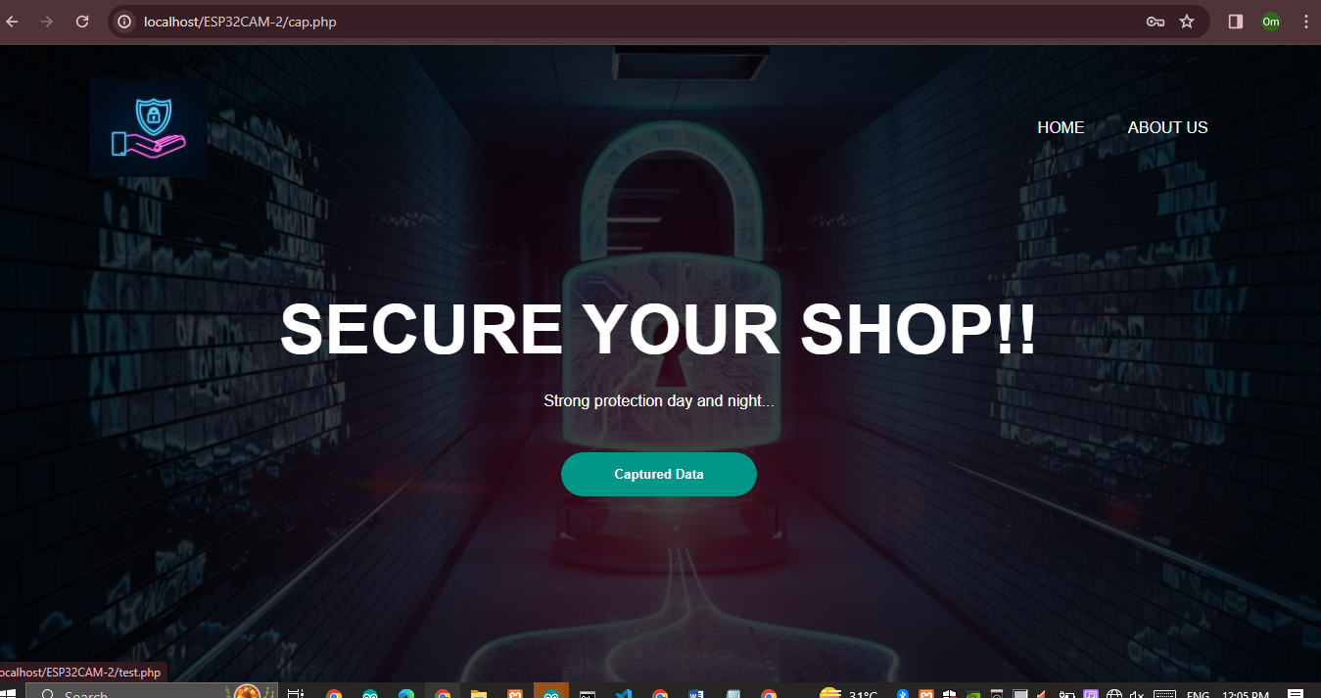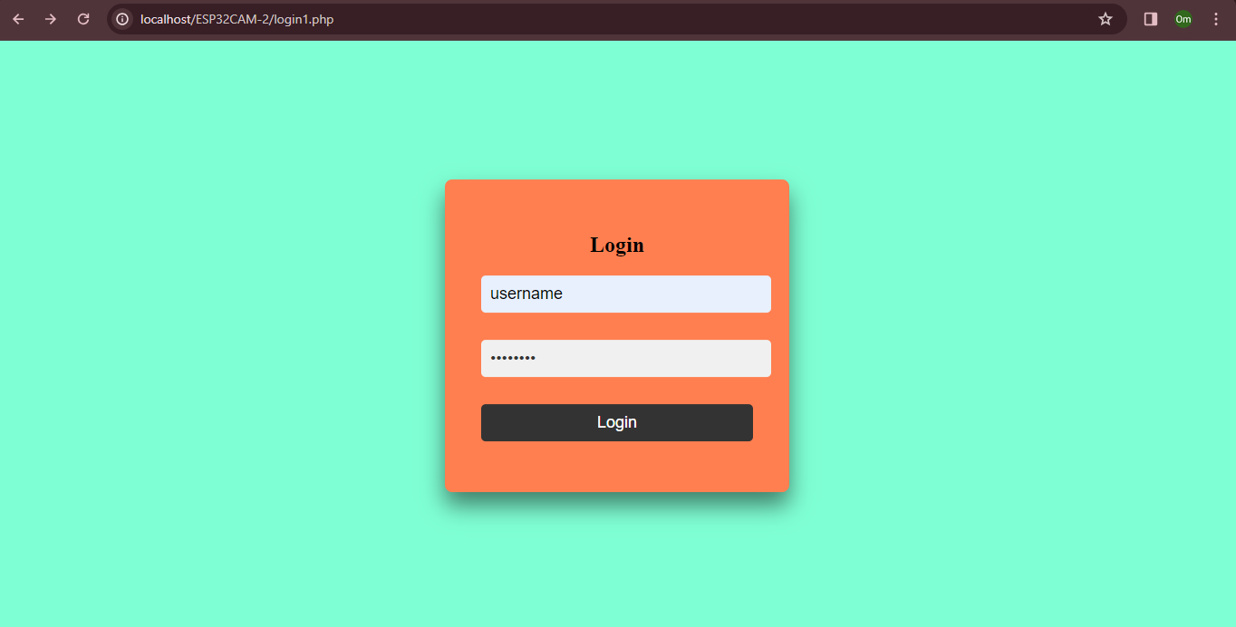

**.2 Strategic approach to sofware testing:**

For software testing we use Arduino IDE software which is an open-source software which is used to write and upload code to the Arduino code. Before connecting the USB,connections are checked throughly for avoid short-circuiting.

1.We can write the code after opening the software.

2.After the completion of code,we need to select the board.The board should be connected with a USB cable.Click at the select board option and sele ct **AI Thinker Board** and select Port COM3.

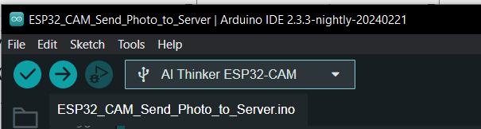

3.  For checking the errors in the code, we can click on the verify option. Errors mostly available would be related to library installations

4. For library installation we can go to "Sketch" "include libraries..". We can select external libraries after downloading it online or through in-build download options.

5.Now we can verify the code:-

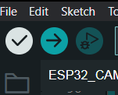

**Verify**

6.If no errors are available then we can prcess towards uploading the code into board by click on the upload option.

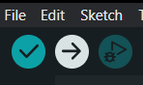

**5.3 Testing Approches:-**

**Upload**

After uploading the code in the **ESP32_CAM** board .we can see the PIR sensor detect the motion and captures the images through ESP32_camera and uploads it on the website which have made and also sends(notify) the photo to owner’s phone. A passive infrared (PIR) sensor is an electronic sensor that measures infrared (IR) light radiating from objects in its field of view.

After gathering all the components, open the [Arduino](https://www.electronicsforu.com/technology-trends/learn-electronics/arduino-basics-schematics) IDE and write the following code (Fig 1).First of all, take a variable for motion sensor pin. Here we have used Arduino digital pin 7. After that create a set-up function and set the Bluetooth baud rate (here we have used baud rate 9600) and set the pin mode for [PIR sensor](https://electronicsforu.com/videos-slideshows/videos/pir-sensor-working-arduino) as input. Then in the next part of the code, create a loop function and under that create an ‘if condition’ that checks the status of motion detection by PIR sensor. When the PIR motion sensor detects any human motion, the Arduino sends a number over Bluetooth to our Android app that we are going to make in next part.

**ESP32_CAM**

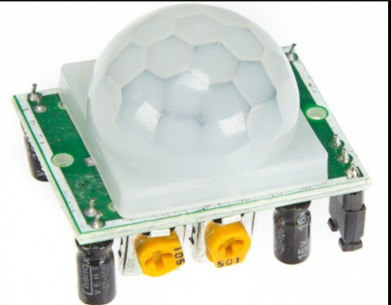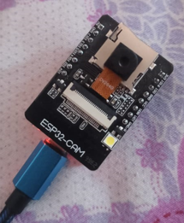

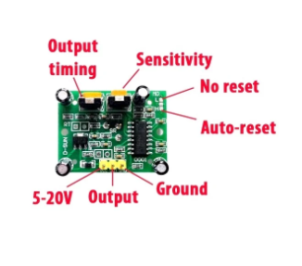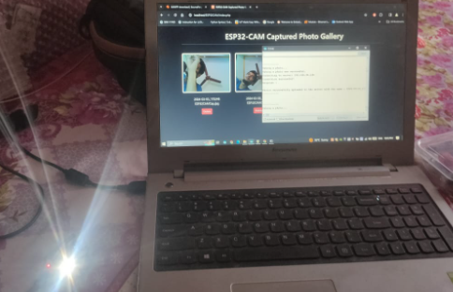

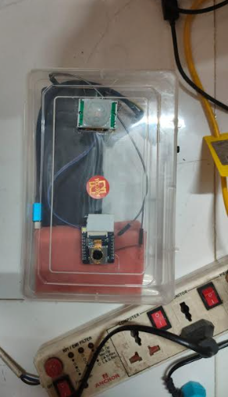**Connections**

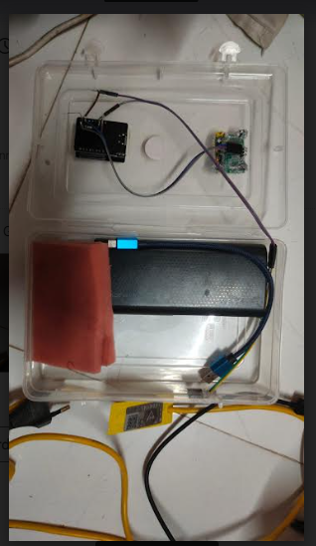

**6.Result and Discussion**

The main objective of this project was to protect shop/home with a  reliable and robust smart security system that can notify us when someone breaks into our shop or home.

When a thief enters a jewellery shop, the shop owner automatically gets a notification on his/her phone. Also, the device automatically calls the cops while the thief is busy stealing the valuables. This is possible with our smart device that we had made.This PIR sensor helps to detect the motion near the door when some one try’s to enter in the shop .

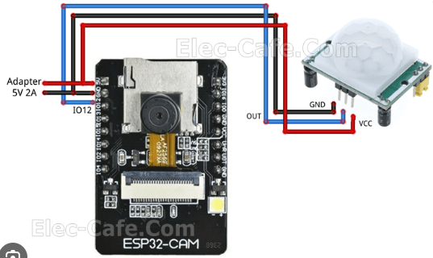

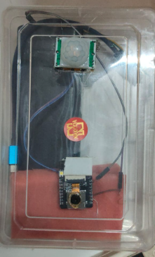 **No motion detected**

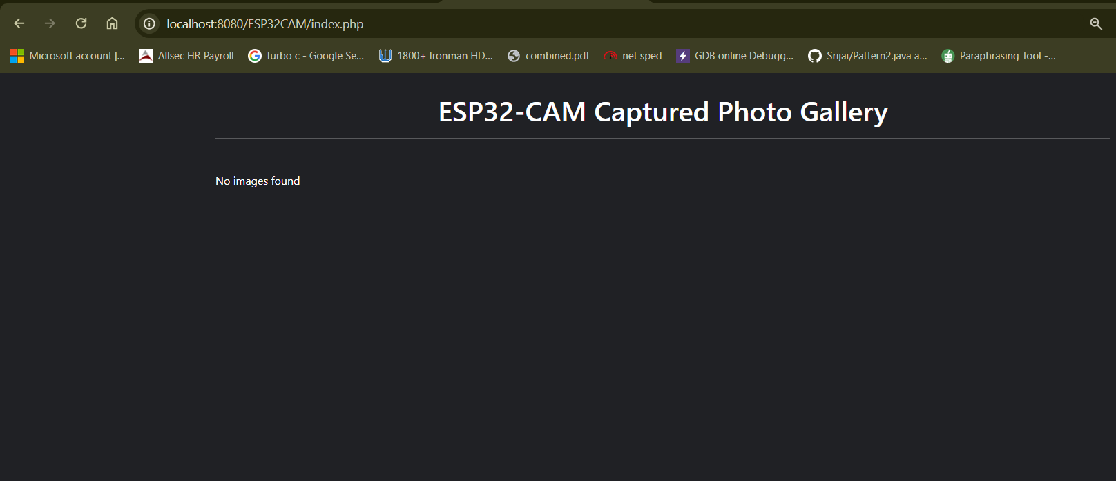

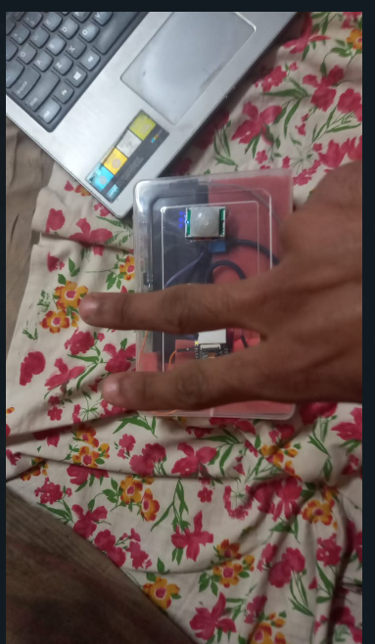

**After Detecting Motion**

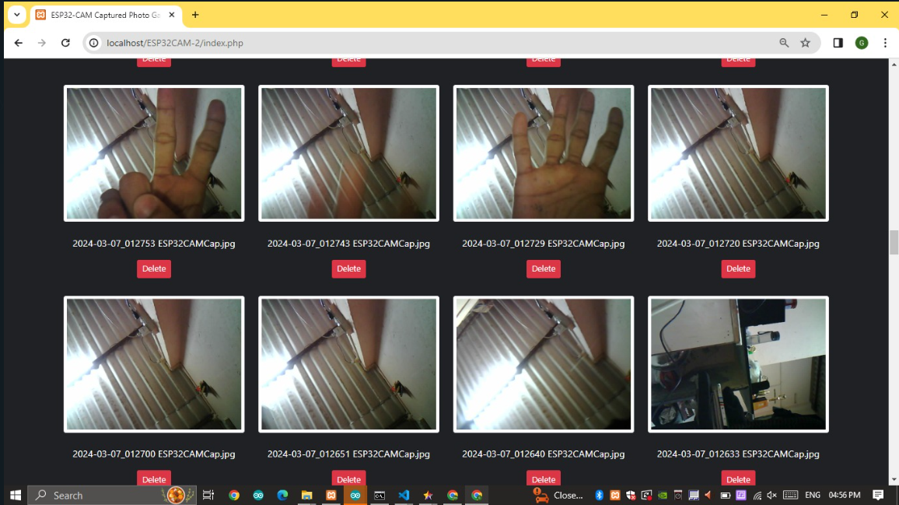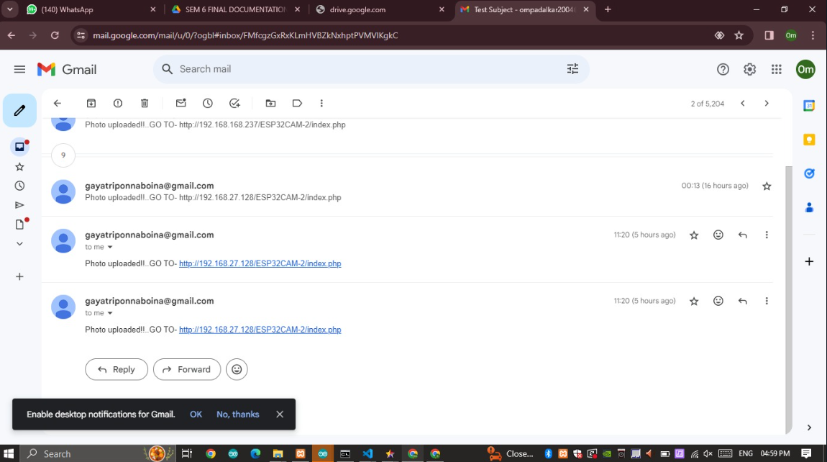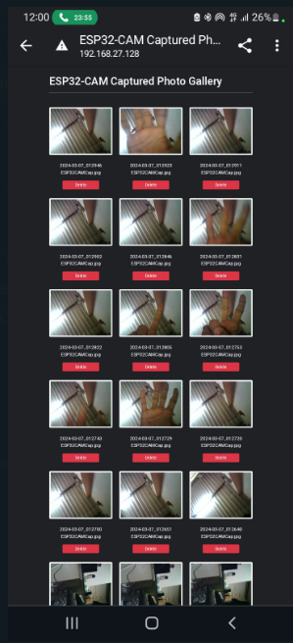 **Chapter 7.Conclusion and Future work**

**Simultaneously Sending Notification to mail**

**After opening the mail we can see images that are captured**

As a result, “Smart jewellery shop security system” is a smart device system offers comprehensive security coverage against intrusions, emergencies.Jewellery shop security system will likely become more integrated with other smart home devices also, doorbell cameras, thermostats, and lighting systems. This integration allows for more comprehensive monitoring and control of the home environment. Additionally, mobile apps will continue to play a significant role in home security systems, allowing homeowners to monitor and control their systems remotely from their smartphones or tablets. Future apps may offer more intuitive interfaces and additional features for managing shop security settings.

Future use for jewellery shop security systems may incorporate advanced sensors and detection technologies, such as motion sensing, and sound detection, to provide more precise and reliable security monitoring.As this systems become more interconnected and collect more data, ensuring the privacy and security of that data will be crucial. Future systems will need to implement robust encryption and privacy measures to protect user data from unauthorized access and misuse.

There are many alternatives technologies used in security. Measures such as installing security cameras, alarm systems, or electronic article surveillance (EAS) gates can help deter potential shoplifters.Over the coming decade,predictions range on how exactly common mechanical devices will change.Wifi connectivity and bluetooth are among the foremost techonolgies we may see.

Overall, the future of home security systems will be characterized by increased integration, intelligence, and customization, with a focus on providing enhanced protection, convenience, and peace of mind for shopowners.

**Chapter 8. References**

Youtube Link :- [https://youtu.be/WHjhRya_16k?si=P45Kxbb DLPQOUlp3](https://youtu.be/WHjhRya_16k?si=P45KxbbDLPQOUlp3)